Right Triangle
# Source: AI Source: Provided by: [Data Path: Persons Table -> ID Column: 1, Name_En Column: Motasem Essam] -> From: [ChatGPT] on [7/25/2026]
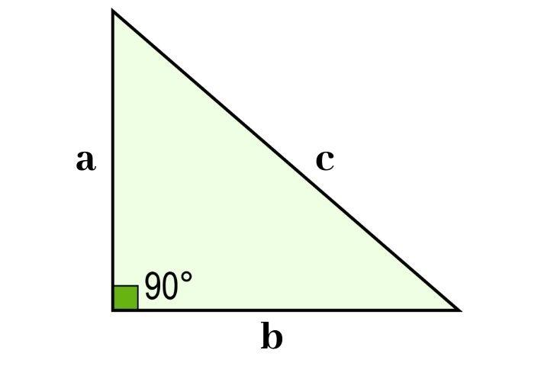
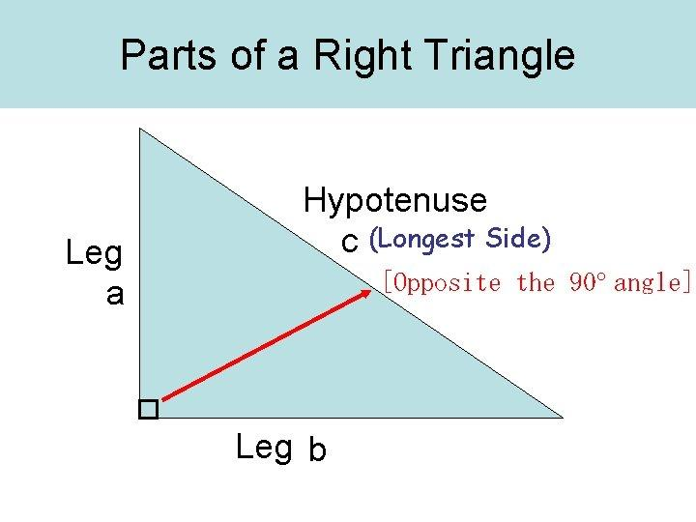
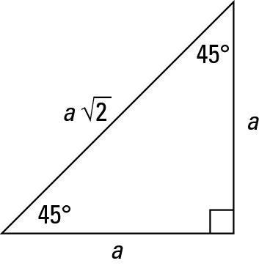
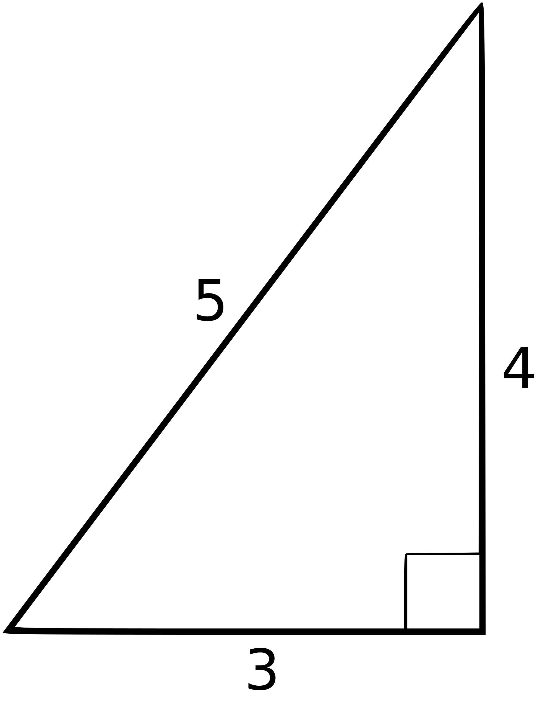
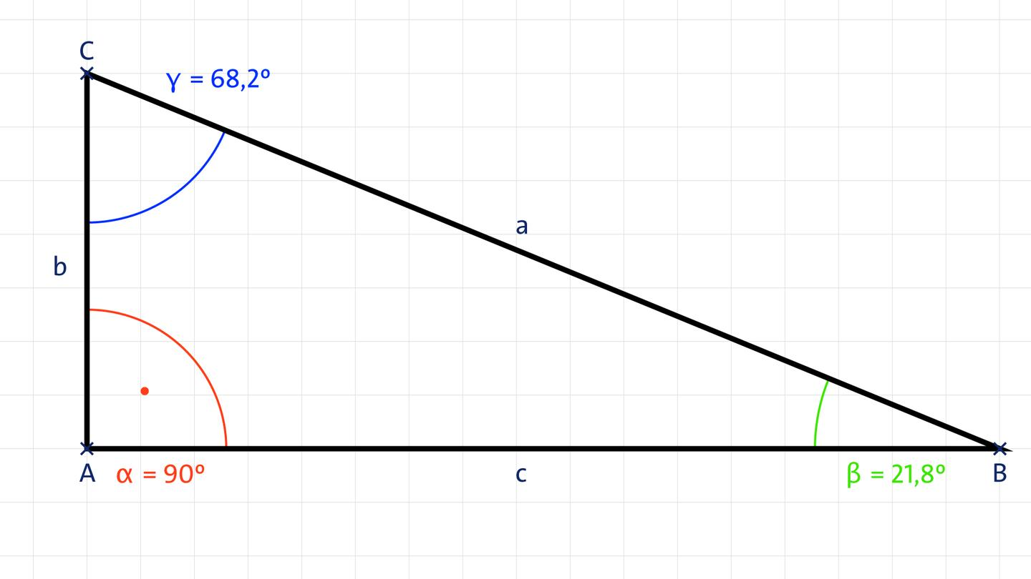

Definition
# Source: AI Source: Provided by: [Data Path: Persons Table -> ID Column: 1, Name_En Column: Motasem Essam] -> From: [ChatGPT] on [7/25/2026]
A Right Triangle is a triangle that has exactly one interior angle equal to ${90}^{∘}$.
For triangle $ABC$, if:
$$\boxed{∠C={90}^{∘}}$$
then $△ABC$is a right triangle.
The other two angles must both be acute, and their sum is:
$$\boxed{∠A+∠B={90}^{∘}}$$

Classification
# Source: AI Source: Provided by: [Data Path: Persons Table -> ID Column: 1, Name_En Column: Motasem Essam] -> From: [ChatGPT] on [7/25/2026]
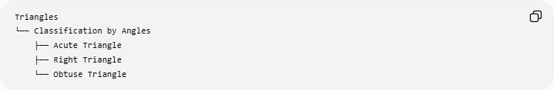
Triangles
└── Classification by Angles
├── Acute Triangle
├── Right Triangle
└── Obtuse Triangle
A right triangle can also be classified according to its sides:
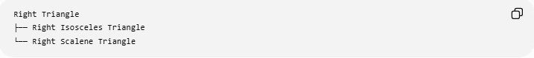
Right Triangle
├── Right Isosceles Triangle
└── Right Scalene Triangle
Important
A right triangle cannot be equilateral, because an equilateral triangle has three ${60}^{∘}$angles.
A right triangle may be:
- Isosceles — two equal legs
- Scalene — three different side lengths

Fundamental Elements
# Source: AI Source: Provided by: [Data Path: Persons Table -> ID Column: 1, Name_En Column: Motasem Essam] -> From: [ChatGPT] on [7/25/2026]
Consider a right triangle $ABC$with:
$$∠C={90}^{∘}$$
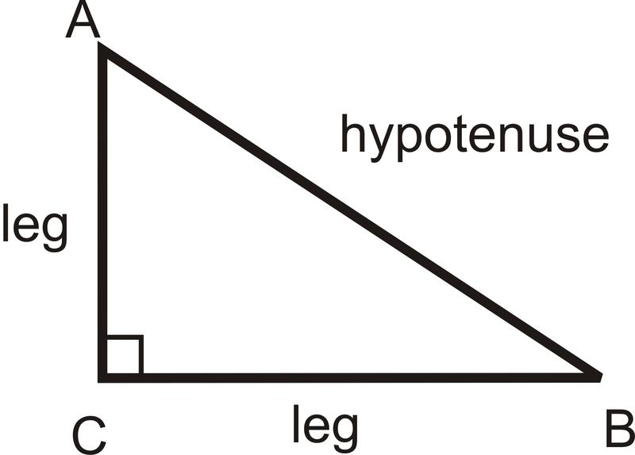
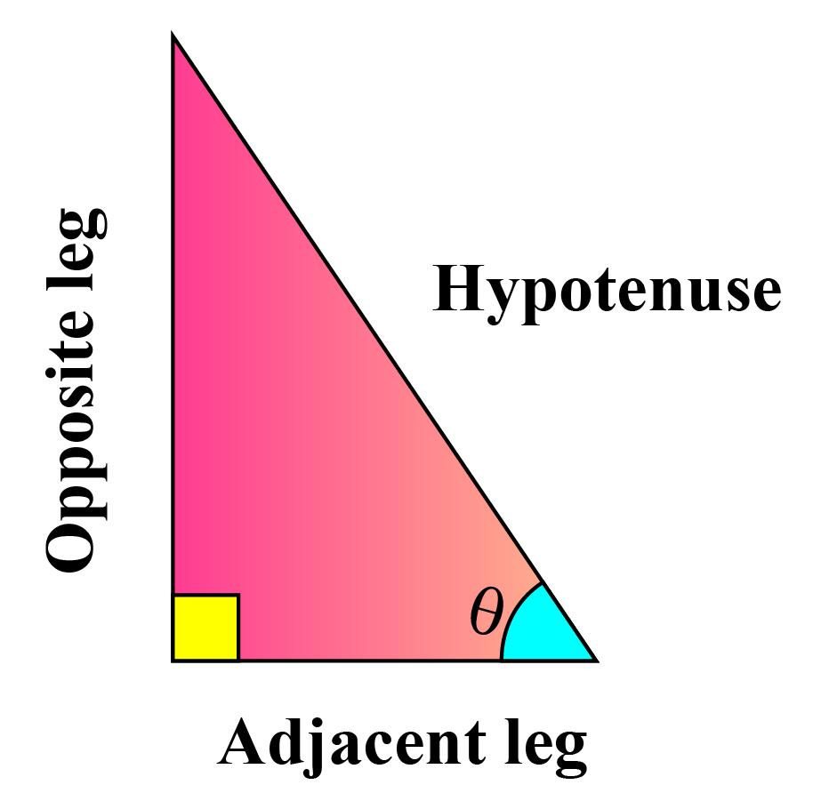
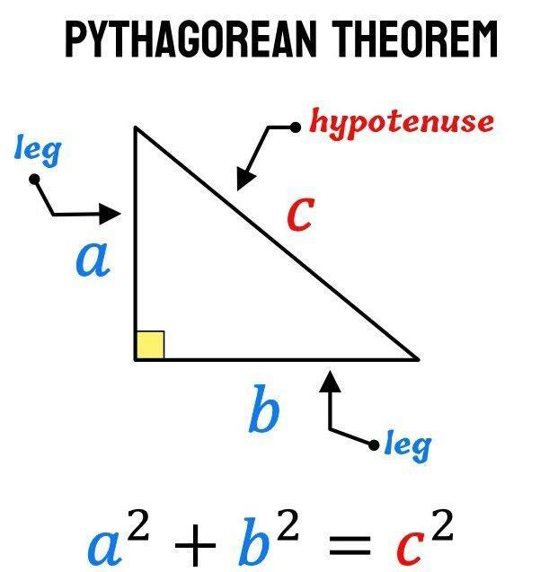
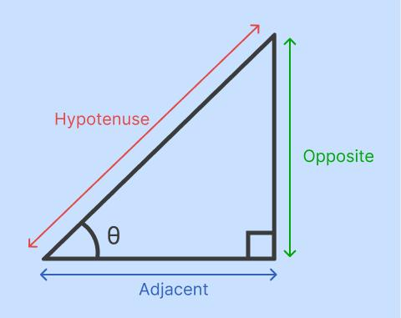
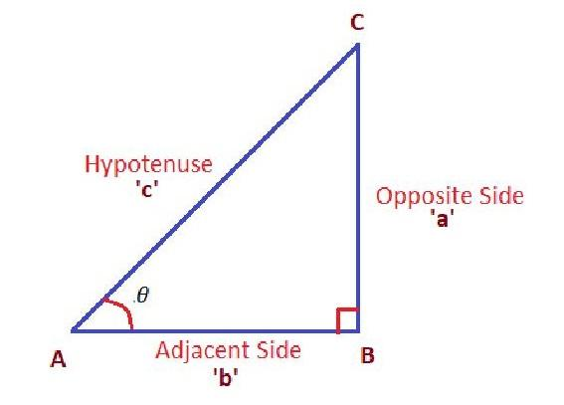

1. Right Angle
# Source: AI Source: Provided by: [Data Path: Persons Table -> ID Column: 1, Name_En Column: Motasem Essam] -> From: [ChatGPT] on [7/25/2026]
The ${90}^{∘}$angle is called the right angle.
It is usually marked with a small square.
$$\boxed{∠C={90}^{∘}}$$

2. Legs
# Source: AI Source: Provided by: [Data Path: Persons Table -> ID Column: 1, Name_En Column: Motasem Essam] -> From: [ChatGPT] on [7/25/2026]
The two sides forming the right angle are called the legs.
In $△ABC$:
$$\boxed{\overset{‾}{AC}\text{ and }\overset{‾}{BC}}$$
are the legs.

3. Hypotenuse
# Source: AI Source: Provided by: [Data Path: Persons Table -> ID Column: 1, Name_En Column: Motasem Essam] -> From: [ChatGPT] on [7/25/2026]
The side opposite the right angle is called the hypotenuse.
Therefore:
$$\boxed{\overset{‾}{AB}}$$
is the hypotenuse.
The hypotenuse is always the longest side of a right triangle.

Pythagorean Theorem
# Source: AI Source: Provided by: [Data Path: Persons Table -> ID Column: 1, Name_En Column: Motasem Essam] -> From: [ChatGPT] on [7/25/2026]
The most important relationship in a right triangle is the Pythagorean theorem.
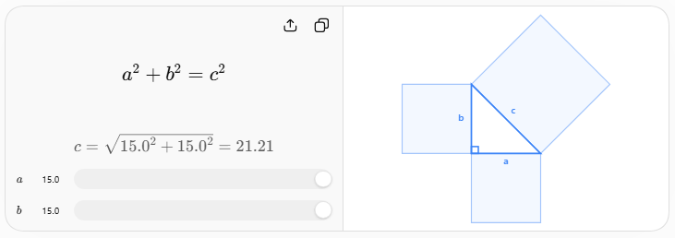
If $a$and $b$are the legs and $c$is the hypotenuse:
$$\boxed{a^{2}+b^{2}=c^{2}}$$
This allows an unknown side to be calculated when the other two sides are known.
Example
Suppose:
$$a=3, b=4$$
Then:
$$c^{2}=3^{2}+4^{2} \\ c^{2}=9+16=25$$
Therefore:
$$\boxed{c=5}$$
This produces the famous 3–4–5 right triangle.

Converse of the Pythagorean Theorem
# Source: AI Source: Provided by: [Data Path: Persons Table -> ID Column: 1, Name_En Column: Motasem Essam] -> From: [ChatGPT] on [7/25/2026]
The Pythagorean relationship can also be used to determine whether a triangle is right.
For the longest side $c$:
$$\boxed{c^{2}=a^{2}+b^{2}}$$
If this equality holds, the triangle is a right triangle.
For example, sides $6,8,10$:
$$6^{2}+8^{2}=36+64=100 \\ {10}^{2}=100$$
Therefore:
$$\boxed{6^{2}+8^{2}={10}^{2}}$$
so the triangle is a right triangle.

Angles
# Source: AI Source: Provided by: [Data Path: Persons Table -> ID Column: 1, Name_En Column: Motasem Essam] -> From: [ChatGPT] on [7/25/2026]
A right triangle has:
- One ${90}^{∘}$angle
- Two acute angles
Because the angles of a triangle sum to ${180}^{∘}$:
$$\boxed{{90}^{∘}+A+B={180}^{∘}}$$
Therefore:
$$\boxed{A+B={90}^{∘}}$$
The two acute angles are therefore complementary angles.

Trigonometric Ratios
# Source: AI Source: Provided by: [Data Path: Persons Table -> ID Column: 1, Name_En Column: Motasem Essam] -> From: [ChatGPT] on [7/25/2026]
Right triangles form the foundation of basic trigonometry.
For an acute angle $θ$:
$$\boxed{\sin{θ}=\frac{\text{opposite}}{\text{hypotenuse}}} \\ \boxed{\cos{θ}=\frac{\text{adjacent}}{\text{hypotenuse}}} \\ \boxed{\tan{θ}=\frac{\text{opposite}}{\text{adjacent}}}$$
These are commonly remembered as:
$$\boxed{\text{SOH-CAH-TOA}}$$
where:
- SOH → Sine = Opposite / Hypotenuse
- CAH → Cosine = Adjacent / Hypotenuse
- TOA → Tangent = Opposite / Adjacent

Special Right Triangles

1. ${45}^{∘}-{45}^{∘}-{90}^{∘}$Triangle
# Source: AI Source: Provided by: [Data Path: Persons Table -> ID Column: 1, Name_En Column: Motasem Essam] -> From: [ChatGPT] on [7/25/2026]
This is a right isosceles triangle.
Its angles are:
$$\boxed{{45}^{∘}, {45}^{∘}, {90}^{∘}}$$
The two legs are equal:
$$\boxed{a=b}$$
The hypotenuse is:
$$\boxed{c=a\sqrt{2}}$$
Therefore, the side ratio is:
$$\boxed{1: 1: \sqrt{2}}$$
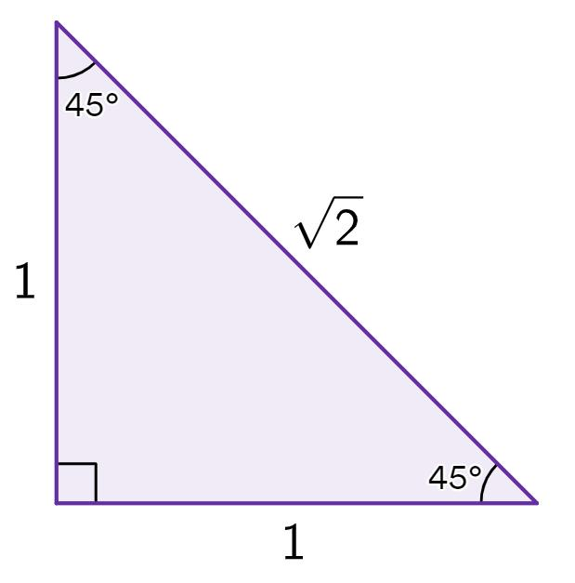
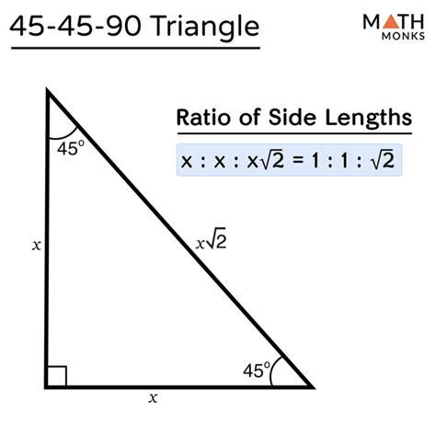
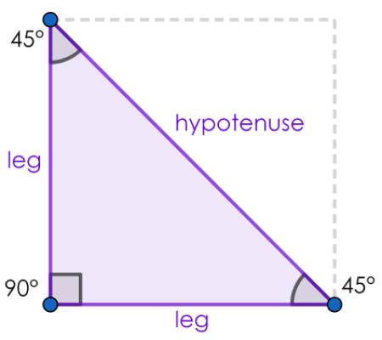
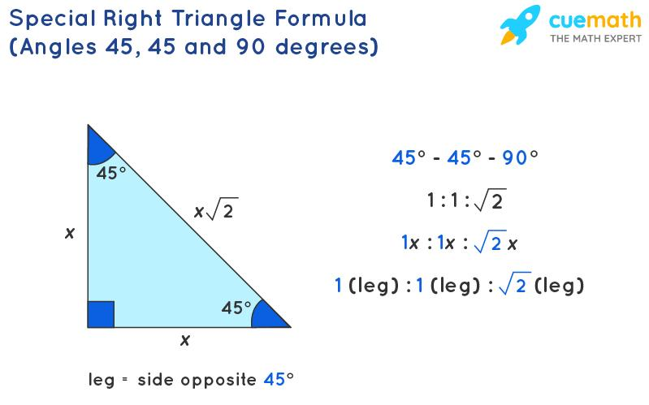

2. ${30}^{∘}-{60}^{∘}-{90}^{∘}$Triangle
# Source: AI Source: Provided by: [Data Path: Persons Table -> ID Column: 1, Name_En Column: Motasem Essam] -> From: [ChatGPT] on [7/25/2026]
This is a right scalene triangle.
Its angles are:
$$\boxed{{30}^{∘}, {60}^{∘}, {90}^{∘}}$$
Its side ratio is:
$$\boxed{1:\sqrt{3}:2}$$
where:
- $1$= side opposite ${30}^{∘}$
- $\sqrt{3}$= side opposite ${60}^{∘}$
- $2$= hypotenuse
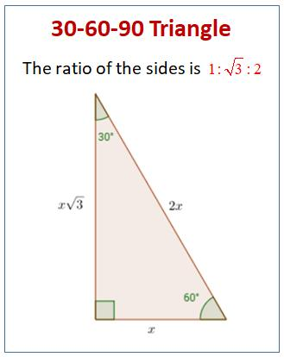
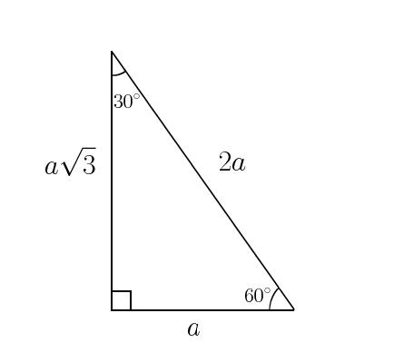
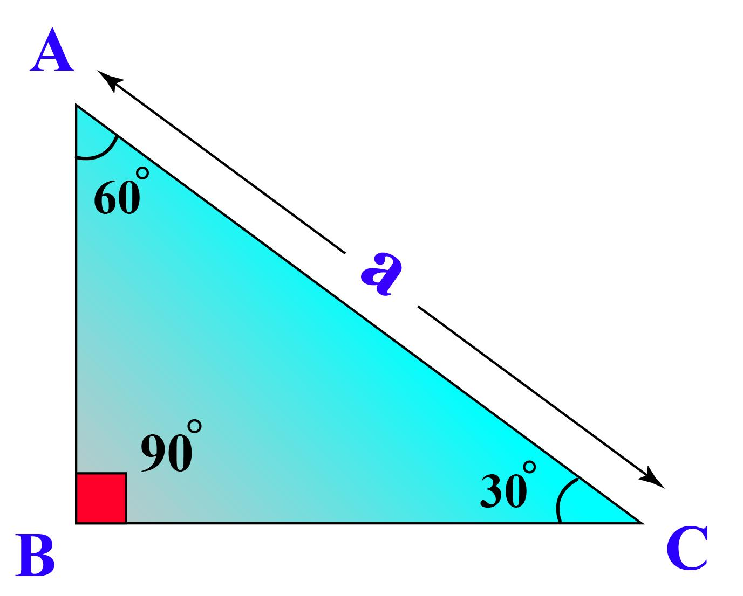
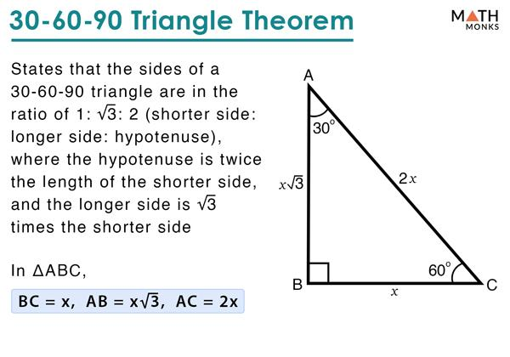

Altitudes and Orthocenter
# Source: AI Source: Provided by: [Data Path: Persons Table -> ID Column: 1, Name_En Column: Motasem Essam] -> From: [ChatGPT] on [7/25/2026]
A right triangle has a particularly simple orthocenter.
The two legs themselves are perpendicular, so they are also two of the triangle's altitudes.
Therefore, the orthocenter is located at the right-angle vertex.
If:
$$∠C={90}^{∘}$$
then:
$$\boxed{H=C}$$
where $H$is the orthocenter.

Circumcenter
# Source: AI Source: Provided by: [Data Path: Persons Table -> ID Column: 1, Name_En Column: Motasem Essam] -> From: [ChatGPT] on [7/25/2026]
The circumcenter of a right triangle lies at the midpoint of the hypotenuse.
If $M$is the midpoint of hypotenuse $AB$:
$$\boxed{O=M}$$
and:
$$\boxed{OA=OB=OC=R}$$
The circumradius is exactly half the hypotenuse:
$$\boxed{R=\frac{c}{2}}$$
This is a special case of Thales' theorem.

Centroid
# Source: AI Source: Provided by: [Data Path: Persons Table -> ID Column: 1, Name_En Column: Motasem Essam] -> From: [ChatGPT] on [7/25/2026]
The centroid $G$is the intersection of the three medians.
Like every nondegenerate triangle:
$$\boxed{G=\text{intersection of the three medians}}$$
It lies inside the right triangle.
For a right triangle with vertices:
$$A=\left(0 , 0\right), B=\left(b , 0\right), C=\left(0 , a\right)$$
the centroid is:
$$\boxed{G=\left(\frac{b}{3} , \frac{a}{3}\right)}$$

Euler Line
# Source: AI Source: Provided by: [Data Path: Persons Table -> ID Column: 1, Name_En Column: Motasem Essam] -> From: [ChatGPT] on [7/25/2026]
The circumcenter $O$, centroid $G$, and orthocenter $H$of a non-equilateral right triangle are collinear.
$$\boxed{O, G, H\text{ are collinear}}$$
and:
$$\boxed{OG:GH=1:2}$$
For a right triangle, $H$is the right-angle vertex and $O$is the midpoint of the hypotenuse.

Area
# Source: AI Source: Provided by: [Data Path: Persons Table -> ID Column: 1, Name_En Column: Motasem Essam] -> From: [ChatGPT] on [7/25/2026]
The area of a right triangle is particularly simple because one leg can serve as the base and the other as the height.
$$\boxed{A=\frac{1}{2}ab}$$
where $a$and $b$are the two legs.
Example
If:
$$a=6, b=8$$
then:
$$A=\frac{1}{2}\left(6\right)\left(8\right) \\ \boxed{A=24}$$

Perimeter
# Source: AI Source: Provided by: [Data Path: Persons Table -> ID Column: 1, Name_En Column: Motasem Essam] -> From: [ChatGPT] on [7/25/2026]
The perimeter is:
$$\boxed{P=a+b+c}$$
For a $3-4-5$triangle:
$$P=3+4+5 \\ \boxed{P=12}$$

Real-World Applications
# Source: AI Source: Provided by: [Data Path: Persons Table -> ID Column: 1, Name_En Column: Motasem Essam] -> From: [ChatGPT] on [7/25/2026]
Right triangles are widely used in:
- Construction
- Architecture
- Surveying
- Engineering
- Navigation
- Astronomy
- Computer graphics
- Land measurement
- Calculating heights and distances
- Ramp and staircase design
For example, a ladder leaning against a wall can form a right triangle:
- wall → one leg
- ground → another leg
- ladder → hypotenuse

Comparison with Other Triangle Types by Angles
# Source: AI Source: Provided by: [Data Path: Persons Table -> ID Column: 1, Name_En Column: Motasem Essam] -> From: [ChatGPT] on [7/25/2026]
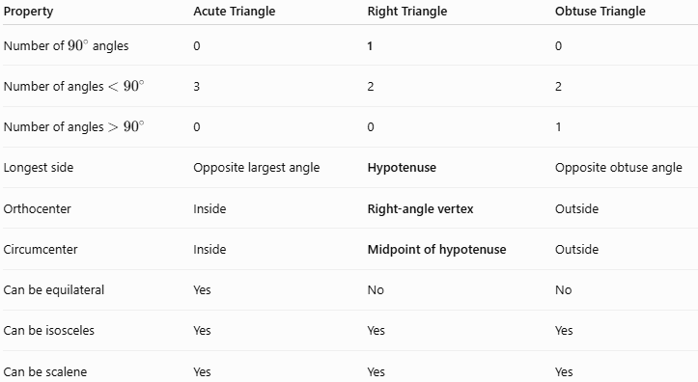
Property | Acute Triangle | Right Triangle | Obtuse Triangle
Number of ${90}^{∘}$angles | 0 | 1 | 0
Number of angles $<{90}^{∘}$ | 3 | 2 | 2
Number of angles $>{90}^{∘}$ | 0 | 0 | 1
Longest side | Opposite largest angle | Hypotenuse | Opposite obtuse angle
Orthocenter | Inside | Right-angle vertex | Outside
Circumcenter | Inside | Midpoint of hypotenuse | Outside
Can be equilateral | Yes | No | No
Can be isosceles | Yes | Yes | Yes
Can be scalene | Yes | Yes | Yes

Right Triangle vs. Right Angle
# Source: AI Source: Provided by: [Data Path: Persons Table -> ID Column: 1, Name_En Column: Motasem Essam] -> From: [ChatGPT] on [7/25/2026]
These concepts should not be confused.
Right Angle
A right angle is an angle measuring exactly:
$$\boxed{{90}^{∘}}$$
Right Triangle
A right triangle is a triangle containing exactly one right angle.
Thus:
$$\boxed{\text{Right Angle}→\text{Geometric Angle}} \\ \boxed{\text{Right Triangle}→\text{Triangle containing a Right Angle}}$$

Key Points
# Source: AI Source: Provided by: [Data Path: Persons Table -> ID Column: 1, Name_En Column: Motasem Essam] -> From: [ChatGPT] on [7/25/2026]
- A right triangle has exactly one ${90}^{∘}$angle.
- The two sides forming the right angle are the legs.
- The side opposite the right angle is the hypotenuse.
- The hypotenuse is always the longest side.
- The Pythagorean theorem is:
$$\boxed{a^{2}+b^{2}=c^{2}}$$
- The two acute angles are complementary.
- The orthocenter is located at the right-angle vertex.
- The circumcenter is the midpoint of the hypotenuse.
- The circumradius is half the hypotenuse:
$$\boxed{R=\frac{c}{2}}$$
- The area is:
$$\boxed{A=\frac{1}{2}ab}$$
- A right triangle can be isosceles or scalene, but never equilateral.
- The two major special right triangles are ${45}^{∘}-{45}^{∘}-{90}^{∘}$and ${30}^{∘}-{60}^{∘}-{90}^{∘}$.

Conclusion
# Source: AI Source: Provided by: [Data Path: Persons Table -> ID Column: 1, Name_En Column: Motasem Essam] -> From: [ChatGPT] on [7/25/2026]
A Right Triangle is a triangle with exactly one ${90}^{∘}$angle. Its two sides forming that angle are the legs, while the opposite side is the hypotenuse. Right triangles are especially important because they provide the basis for the Pythagorean theorem, trigonometric ratios, distance calculations, and many geometric and practical applications.

